Course Title | AUDIT COURSE: HEALTH & WELLNESS
Code | U24PE3HWT01
Course Type | Theory & Practical
Semester | III
Total Hours | 15
Hours/Week | 1 Hr/Wk
Credits | 1
Marks | 100

UNIT I – INTRODUCTION TO HEALTH & WELLNESS
DEFINITION
Health is a state of complete physical, mental, and social well-being, not merely the absence of disease or infirmity. An active process of making choices and taking actions to achieve optimal health and well-being. – WORLD HEALTH ORGANISTION.
CONCEPT OF HEALTH AND WELLNESS
Health is a relative state in which one is able to function well physically, mentally, socially, and spiritually to express the full range of one's unique potentialities within the environment in which one lives. Wellness is the active pursuit of activities, choices, and lifestyles that lead to a state of holistic health and well-being, encompassing physical, mental, emotional, and social dimensions. It's not merely the absence of disease but a proactive, ongoing process of self-improvement and positive life choice.
MEANING OF WELLNESS WHEEL
A wellness wheel is a simple tool that can help you see the bigger picture of your overall health by dividing it into several parts, or “dimensions”: social, occupational, environmental, intellectual, spiritual, emotional, physical, and financial. It helps individuals identify areas of strength and areas needing improvement, promoting a holistic approach to health and encouraging a balanced lifestyle

EXPLORING THE 8 DIMENSIONS OF THE WELLNESS WHEEL
The wellness wheel is made up of eight different dimensions, each representing a key part of life that contributes to your overall wellbeing. Each of these dimensions is important on its own, but they’re all interconnected — and when one is out of balance, it can affect the others. The wellness wheel helps you visualize and organize your life, allowing you to identify where you need to make changes to be happier and healthier.
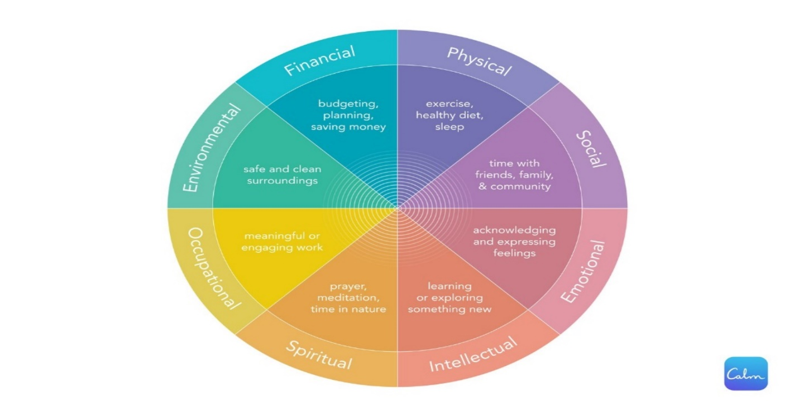
PHYSICAL WELL-BEING
Physical wellness is the dimension of overall well-being that focuses on taking care of your body, including physical activity, healthy eating, and sufficient sleep. It encompasses maintaining a healthy weight, managing stress, preventing illness and injury, and responding appropriately to health issues. Essentially, it's about making conscious choices to support your body's health and vitality. When you prioritize your physical wellness, you’re laying the foundation for a healthy life filled with activities you love. 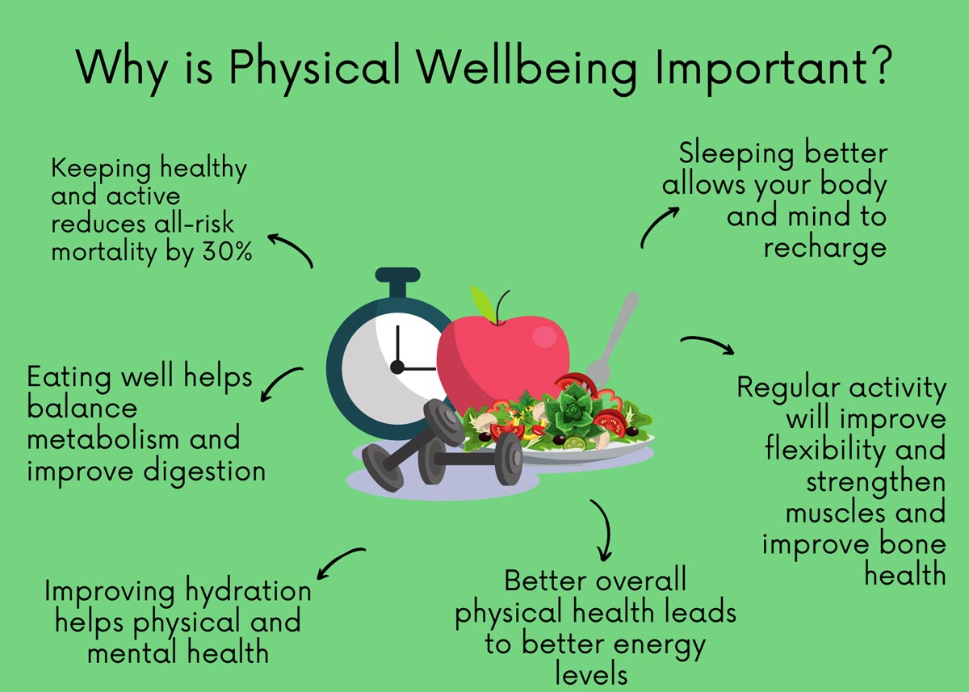
Physical Activity:
Engaging in regular exercise, whether it's walking, swimming, or strength training, is crucial for maintaining physical wellness.
Healthy Eating:
Consuming a balanced diet that provides your body with the necessary nutrients is essential for optimal functioning.
Sufficient Sleep:
Getting enough sleep is vital for physical and mental restoration, allowing your body to repair and rejuvenate itself.
Weight Management:
Maintaining a healthy weight reduces the risk of various health problems associated with obesity.
Stress Management:
Learning to manage stress through various techniques can positively impact both physical and mental health.
Preventing Illness and Injury:
Making informed choices about health behaviors, such as avoiding harmful substances and practicing safety measures, can help prevent illness and injury.
Responding to Health Issues:
Seeking appropriate medical care when needed and following recommended treatment plans are important aspects of physical wellness.
Overall Well-being:
Physical wellness is intrinsically linked to overall well-being, impacting mood, energy levels, and ability to participate in daily activities.
SOCIAL WELL-BEING
Social wellness refers to the ability to build and maintain healthy relationships with others, fostering a sense of belonging and connection. It involves cultivating positive interactions, communicating effectively, and participating in social groups and communities. Ultimately, social wellness contributes to overall well-being by providing support, resilience, and a sense of purpose.

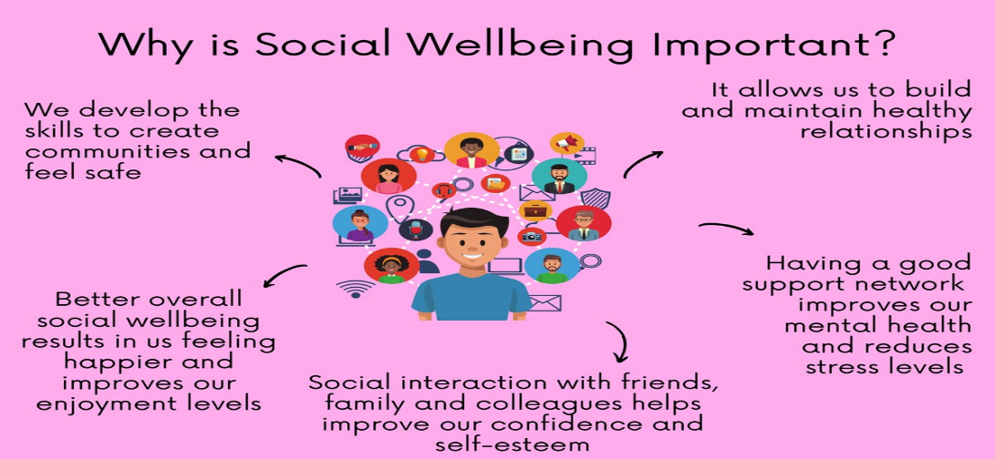

EMOTIONAL WELLNESS
Emotional wellness refers to the ability to understand, accept, and manage one's emotions, as well as the capacity to cope with life's challenges and build healthy relationships. It's about developing skills to navigate both positive and negative emotions, fostering a sense of well-being, and adapting to change and difficult times.
MENTAL WELLBEING
Mental wellbeing, also known as psychological wellbeing, is a state of positive emotional, psychological, and social health where individuals can function effectively, cope with life's challenges, and experience contentment and fulfillment. It's not just the absence of mental illness, but a positive state of overall wellness.
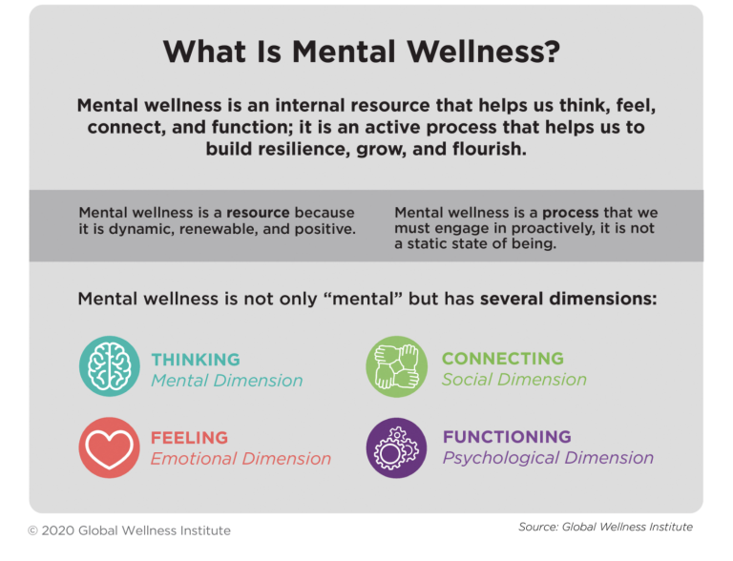
INTELLECTUAL WELL-BEING
Intellectual well-being refers to the engagement in mentally stimulating activities that foster curiosity, critical thinking, and creativity, leading to a sense of satisfaction and intellectual growth. It involves continuously learning, expanding knowledge, and applying newly acquired skills in meaningful ways, both personally and within communities.
ENVIRONMENTAL WELL-BEING
Environmental well-being, also known as environmental wellness, refers to the state of having a safe, healthy, and comfortable environment that supports both human and ecological health. It encompasses an understanding of our relationship with our surroundings and taking actions to promote sustainability, reduce harm, and enhance the quality of life for all.
THE IMPORTANCE OF THE WELLNESS WHEEL:
1. HOLISTIC PERSPECTIVE: The wellness wheel provides a comprehensive view of health, moving beyond just physical well-being to encompass mental, emotional, social, and other aspects of life.
2. SELF-AWARENESS: By evaluating each dimension, individuals gain a deeper understanding of their current state of well-being, identifying strengths and areas where they may need more attention.
3. PRIORITIZATION: The wellness wheel helps individuals prioritize areas that require focus and development, enabling them to make informed decisions about their health and lifestyle.
4. BALANCE AND INTEGRATION: It emphasizes the interconnectedness of different dimensions, encouraging individuals to strive for balance and integration across all areas of their lives.
5. GOAL SETTING: The insights gained from the wellness wheel can be used to set meaningful and personalized wellness goals, guiding individuals in their journey towards optimal well-being.
6. INCREASED WELL-BEING: By addressing the various dimensions of wellness, individuals can experience increased levels of happiness, fulfillment, and overall well-being.
7. STRESS MANAGEMENT: The wellness wheel can help in identifying sources of stress and provide strategies for managing and reducing stress levels.
8. PROACTIVE HEALTH MANAGEMENT: It encourages individuals to take a proactive approach to their health, making positive choices and developing healthy habits that support their overall well-being.
9. ENHANCED RESILIENCE: By fostering a balanced and holistic approach to health, the wellness wheel can contribute to increased resilience and the ability to cope with life's challenges.
10. IMPROVED RELATIONSHIPS: The social dimension of the wellness wheel highlights the importance of relationships and social connections, which can lead to improved communication, support systems, and overall social well-being.
ROLE OF EXERCISE IN DAILY LIFE
Regular physical activity can improve your muscle strength and boost your endurance. Exercise sends oxygen and nutrients to your tissues and helps your cardiovascular system work more efficiently. And when your heart and lung health improve, you have more energy to tackle daily chores.
PHYSICAL HEALTH BENEFITS:
Disease Prevention
Weight Management
Improved Cardiovascular Health
Stronger Bones and Muscles
Increased Energy Levels
MENTAL HEALTH BENEFITS:
Mood Enhancement
Stress Reduction
Improved Cognitive Function
Better Sleep
ROLE OF NUTRITION IN DAILY LIFE
Nutrients have one or more of three basic functions: they provide energy, contribute to body structure, and/or regulate chemical processes in the body. Good nutrition is essential for daily life as it provides the body with the necessary fuel and building blocks for optimal function, growth, and health. It impacts everything from energy levels and physical performance to disease prevention and mental well-being.

UNIT II – PHYSICAL FITNESS AND HEALTHY LIFE STYLE
INTRODUCTION TO PHYSICAL FITNESS
Fitness is a condition in which an individual has sufficient energy to avoid fatigue and enjoy life. “The ability to perform daily tasks vigorously and alertly, with energy left over for enjoying leisure time activities and meeting emergency demands. It is the ability to endure, to bear up, to withstand stress, to carry on in circumstances where an unfit person could not continue, and is a major basis for good health and well-being.”
“Physical Fitness refers to the organic capacity of the individual to perform the normal task of daily living without undue tiredness or fatigue having reserves of strength and energy available to meet satisfactorily any emergency demands suddenly placed upon him” -Nixon
BENEFITS OF PHYSICAL FITNESS
I – IMPROVED HEALTH
Increased efficiency of heart and lungs.
Reduced cholesterol levels.
Increased muscle strength.
Reduced blood pressure.
Reduced risk of major illnesses such as diabetes and heart disease.
Weight loss.
II – IMPROVED SENSE OF WELL- BEING
More energy
Less stress
Improved quality of sleep
Improved ability to cope with stress.
Increased mental sharpness.
III – IMPROVED APPEARANCE
Weight loss
Toned muscles
Improved posture.
IV – ENHANCED SOCIAL LIFE
Improved self-image
Increased opportunities to make new friends.
Increased opportunities to share an activity with friends or family members.
V – INCREASED STAMINA
Increased productivity.
Increased physical capabilities.
Less frequent injuries.
Improved immunity to minor illnesses.
Physical fitness is divided into four health and six skill-related components. Skill- or performance-related fitness involves skills that will enhance one’s performance in athletic or sports events. Health-related fitness involves skills that enable one to become and stay physically healthy.
CLASSIFICATION OF PHYSICAL FITNESS
Health Related Physical Fitness- Cardiovascular endurance, muscular strength, muscular endurance, body composition and flexibility.
Skill Related Physical Fitness- Speed, Agility, Balance, Coordination, Power, Reaction Time
I-Health Related Fitness
Cardiovascular endurance
Cardiovascular endurance is the ability of the body's circulatory and respiratory systems to supply fuel during sustained physical activity. To improve your cardiovascular endurance, try activities that keep your heart rate elevated at a safe level for a sustained length of time such as walking, swimming, or bicycling. The activity you choose does not have to be strenuous to improve your cardiovascular endurance. Start slowly with an activity you enjoy, and gradually work up to a more intense pace.
Muscular strength
Muscular strength is the ability of the muscle to exert force during an activity. The key to making your muscles stronger is working them against resistance, whether that be from weights or gravity. If you want to gain muscle strength, try exercises such as lifting weights or rapidly taking the stairs.
Muscular endurance
Muscular endurance is the ability of the muscle to continue to perform without fatigue. To improve your muscle endurance, try cardio-respiratory activities such as walking, jogging, bicycling, or dancing.
Body composition
Body composition refers to the relative amount of muscle, fat, bone, and other vital parts of the body. A person's total body weight (what you see on the bathroom scale) may not change over time. But the bathroom scale does not assess how much of that body weight is fat and how much is lean mass (muscle, bone, tendons, and ligaments). Body composition is important to consider for health and managing your weight!
Flexibility
Flexibility is the range of motion around a joint. Good flexibility in the joints can help prevent injuries through all stages of life. If you want to improve your flexibility, try activities that lengthen the muscles such as swimming or a basic stretching program.
II- Skill-Related Fitness
Agility is the ability to change and control the direction and position of the body while maintaining a constant, rapid motion. For example, changing directions to hit a tennis ball. •
Balance is the ability to control or stabilize the body when a person is standing still or moving. For example, in-line skating.
Coordination is the ability to use the senses together with body parts during movement. For example, dribbling a basketball. Using hands and eyes together is called hand-eye coordination. •
Speed is the ability to move your body or parts of your body swiftly. Many sports rely on speed to gain advantage over your opponents. For example, a basketball player is making a fast break to perform a layup, a tennis player moving forward to get to a drop shot, a football player out running the defense to receive a pass.
Power is the ability to move the body parts swiftly while applying the maximum force of the muscles. Power is a combination of both speed and muscular strength. For example, fullbacks in football muscling their way through other players and speeding to advance the ball and volleyball players getting up to the net and lifting their bodies high into the air.
Reaction Time is the ability to reach or respond quickly to what you hear, see, or feel. For example, an athlete quickly coming off the blocks early in a swimming or track relay, or stealing a base in
HEALTHY LIFE
MEANING OF YOGA
“The practice of yoga makes the body strong and flexible; it also improves the functioning of the respiratory, circulatory, digestive, and hormonal systems. Yoga brings about emotional stability and clarity of mind. In the practice of Yoga the ultimate aim is one of
self-development and self-realization”
BENEFITS OF YOGA
1. The benefits of Yoga are numerous, including physical fitness, stress control, general wellbeing. Mental clarity and greater self-understanding. People of all ages can practice Yoga, even physically challenged people can also adopt.
2. Yoga improves posture; yoga can be seen not only as a way to get into shape but also as a tool for self-healing. Increases the intake of oxygen and enhances the functioning of all body systems like respiratory, digestive, endocrine, reproductive, excretory systems etc.
3. It’s effects on the emotions are equally beneficial by calming down the mind.
4. Yoga also cures behavioral disorders, nervous breakdown and manic depressions
5. Asanas enhance muscle strength, coordination, flexibility, agility and range of motion.
6. Yoga gives you the capacity to face up the life’s challenges. When you respect your body, you tend to do things that will enhance its vitality.
7. Yoga helps to maintain the acid-alkaline ratio. This is crucial to good health. It should be 80% alkaline and 20% acidic. Over acidity can be harmful for bones and tissues, leading to fatigue, dulled mind, headaches, depressions and arthritis.
8. Yoga is highly recommended for the people in competitive, stressful working environments.
9. Practicing Yoga ultimately leads towards long-term health and well-being after a good practice of Yoga, the mind becomes vibrant. Much healing can be done, but it takes practice and consistency.
10. In Yoga, one should concentrate on a total awareness of our energy and how it flows. One should learn how body and mind works together.
TYPES OF YOGA
Paths (Margas) of Yoga
Yoga – control of the mind, the way of the reflective person
Bhakti –yoga of devotion, the way of the emotional person
Jnana – yoga of wisdom, the way of the intellectual person
Karma –yoga of action, the way of the active person
Hatha – physical discipline of yoga (postures and breathing practices)
Raja – yoga of complete mastery of the self (also, Patanjali’s Ashtanga Yoga)
Tantra – the universe seen as the divine play of Shakthi and Shiva
MEDITATION
Meditation is a deliberate process of focusing attention to achieve a mentally clear and emotionally calm state. It involves using techniques like breath awareness, mantra repetition, or focusing on an object to train the mind.
BENEFITS OF MEDITATION:
Stress Reduction:
Meditation helps calm the nervous system and reduce the body's stress response.
Improved Focus and Concentration:
Regular practice can enhance attention span and cognitive function.
Emotional Regulation:
Meditation can help individuals become more aware of their emotions and develop healthier coping mechanisms.
Increased Self-Awareness:
It can promote a deeper understanding of oneself, including thoughts, feelings, and behaviors.
Better Sleep:
Meditation can improve sleep quality by calming the mind and reducing racing thoughts.
Pain Management:

BRAIN HEALTH
Brain health is the state of brain functioning across cognitive, sensory, social-emotional, behavioral and motor domains, allowing a person to realize their full potential over the life course, irrespective of the presence or absence of disorders.
HEALTHY LUNGS
Healthy lungs are essential for overall well-being, allowing for efficient oxygen intake and carbon dioxide removal. Maintaining lung health involves a combination of lifestyle choices, environmental awareness, and proactive measures. Key strategies include avoiding smoking and secondhand smoke, staying physically active, maintaining a healthy weight, and managing exposure to air pollution and indoor irritants.
HYGIENE
"Hygiene refers to conditions and practices that help to maintain health and prevent the spread of diseases." - World Health Organization.
PERSONAL HYGIENE
Personal hygiene refers to regularly washing parts of the body and hair with soap and water (including washing your hands and feet), grooming nails, facial cleanliness, covering coughs and sneezes, and menstrual hygiene. Personal hygiene practices can help you to feel fresh and healthy.
GROOMING
Personal grooming is about having habits and practices of maintaining one's appearance and hygiene. It goes beyond positive lifestyle choices. From skincare routines to clothing choices, in daily life.
DAILY ROUTINE
A daily routine is a set of actions you perform every day, like waking up at the same time or hitting the gym each evening. Not all routines center positive behaviors like exercise or a solid sleep schedule.
EVERY ROUTINE IS POWERFUL.
Take a cold shower.
Prepare goals for the next day.
Reflect on your daily achievements.
Clear your head.
Prepare for the next morning.
Tidy up.
Take a walk after dinner.
Practice proper sleep hygiene. Very few people practice proper sleep hygiene, and their sleep suffers as a result.
Daily Good habits to have in life
Exercise
Learn something new
Meditation
Practice gratitude
Acknowledge gratitude
Drinking water
Self-care
Sleep hygiene
Kindness
Limit screen time
Make your bed
Practice mindfulness
Consistent routines Declutter
Have breakfast
Journaling
Move Your Body
Wake up early
Healthy diet

SLEEP TIME
Age group | Recommended amount of sleep
3 to 5 years | 10 to 13 hours per 24 hours, including naps
6 to 12 years | 9 to 12 hours per 24 hours
13 to 18 years | 8 to 10 hours per 24 hours
Adults | 7 or more hours a night

MEAL TIME
Lunch. Lunch should be about four to five hours after breakfast. For example, if you ate breakfast at 7 am, eat lunch between 11 am and noon. If it is not possible for you to eat lunch until 2 pm on a particular day, then plan a snack in between those two meals.
UNIT III – STRESS MANAGEMENT AND MENTAL HEALTH
STRESS
Stress is a natural human reaction that happens to everyone. In fact, your body is designed to experience stress and react to it. When you experience changes or challenges (stressors), your body produces physical and mental responses that is called stress.
TYPES OF STRESS
There are three main kinds of stress: acute, episodic acute and chronic.
Acute stress: Acute stress is short-term stress that comes and goes quickly. It can be positive or negative. It’s the feeling you get when you’re riding on a rollercoaster or having a fight with your boyfriend. Everyone experiences acute stress from time to time.
Episodic acute stress: Episodic acute stress is when you experience acute stress on a regular basis. With this kind of stress, you don’t ever get the time you need to return to a calm, relaxed state. Episodic stress frequently affects people working in certain professions, like healthcare providers.
Chronic stress: Chronic stress is long-term stress that goes on for weeks or months. You may experience chronic stress due to marriage troubles, issues at work or financial problems. It’s important to find ways to manage chronic stress because it can lead to health issues.
SYMPTOMS OF STRESS
Physical symptoms, psychological symptoms, Behavioral symptoms
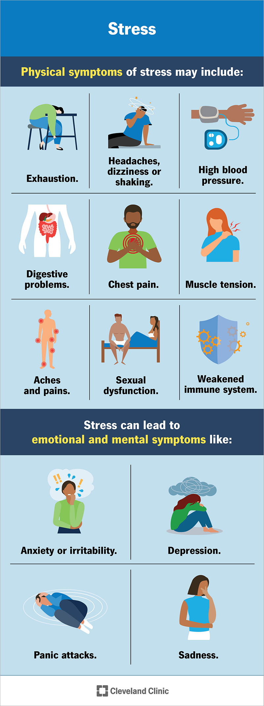
MANAGEMENT AND TREATMENT
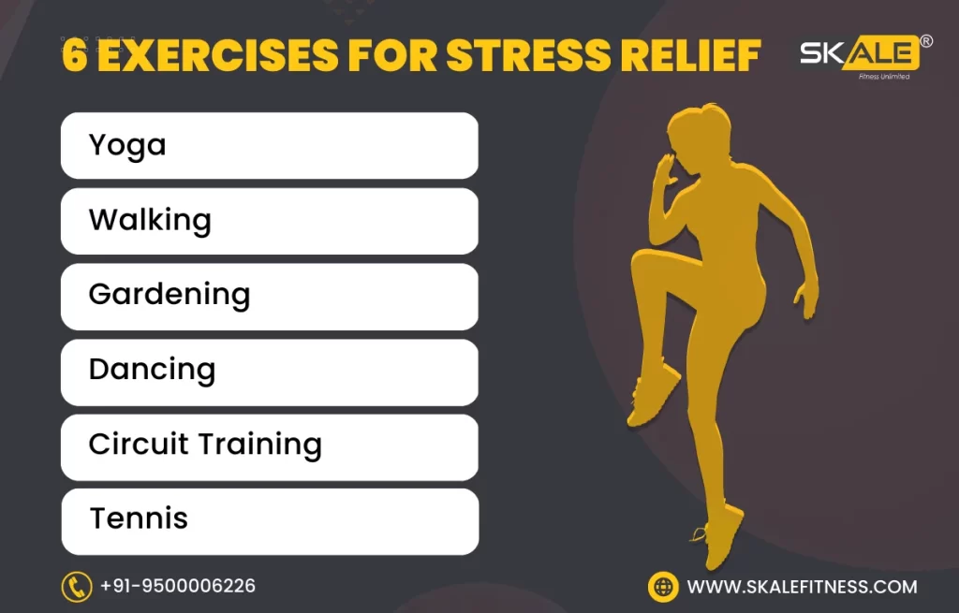
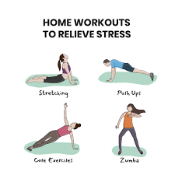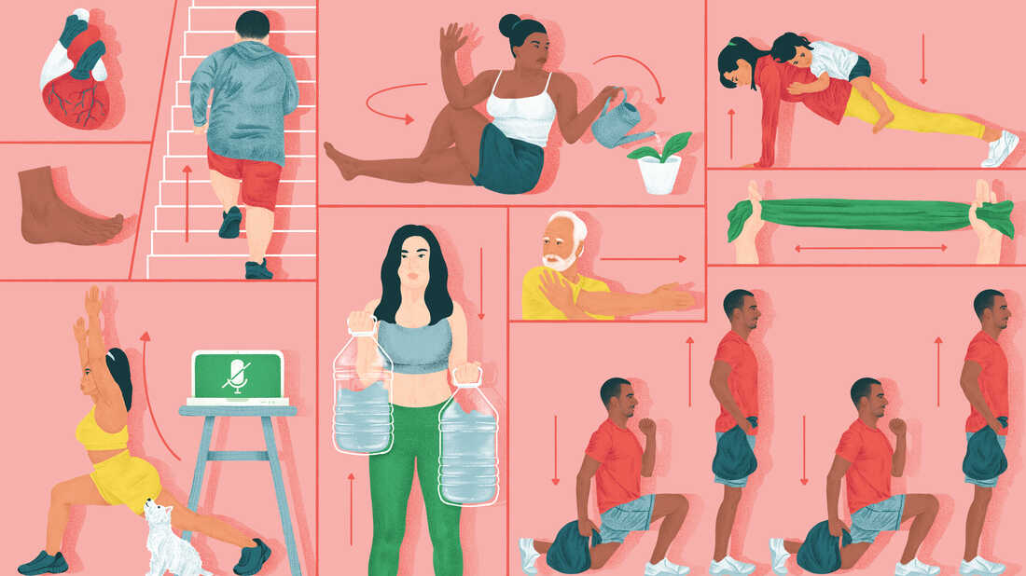
UNIT IV – AWARENESS ON SUBSTANCE ABUSE
Substances change how your brain functions over time. They release dopamine, a chemical in your brain that makes you feel good — until the substance wears off. Your brain and body want to continue this good feeling, even if it’s unhealthy. It can significantly impact your emotional well-being, relationships, education and career. And in many cases, it’s life-threatening.
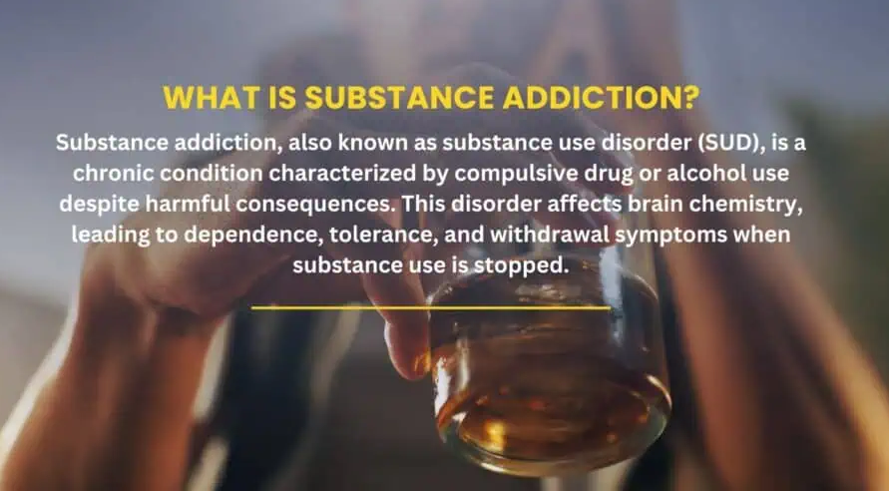
substance addictions exists on a spectrum and may be mild, moderate or severe. No matter where you are, know that this condition is treatable and help is available when you’re ready.
SYMPTOMS OF SUBSTANCE ADDICTION
Include alcohol, nicotine, cannabis, food, hallucinogens, inhalants, opioids, prescription medications, and stimulants, each with distinct patterns of dependency and health risks. Common signs of these addictions are compulsive use, increased tolerance, withdrawal symptoms, and continued use despite negative consequences.
Common signs of substance abuse include sudden weight changes, altered pupil size, bloodshot eyes, and psychological signs such as using substances to manage emotions and experiencing cravings. Behavioral indicators involve spending excessive time on substance-related activities and neglecting responsibilities. These symptoms can vary based on the substance used, duration of use, and individual traits, with physical signs like slurred speech and changes in appearance also prevalent. Recognizing these symptoms is crucial for early intervention and effective treatment.
Examples of substance addiction include behaviors associated with alcohol, such as preoccupation with drinking, prioritizing it over responsibilities, and experiencing withdrawal symptoms. In contrast, social drinking, like a college student enjoying drinks with friends, does not indicate addiction unless it leads to personal or legal issues. Recognizing warning signs, such as loss of control and relationship problems, is crucial for identifying addiction and seeking help.
Common causes of substance addiction include genetic predisposition, where certain individuals are more susceptible due to specific genetic factors. The brain’s response to substances also plays a role, as drugs trigger the release of dopamine, reinforcing addictive behaviors. Additionally, early childhood trauma and social influences, such as peer pressure, significantly increase the risk of developing addiction later in life.
Common risks of substance abuse addiction include mental health issues like anxiety and depression, severe physical effects from drug overdoses, and disruptions to personal life, including strained family dynamics and social isolation. Comprehensive treatment is essential to address these interconnected challenges and support recovery.

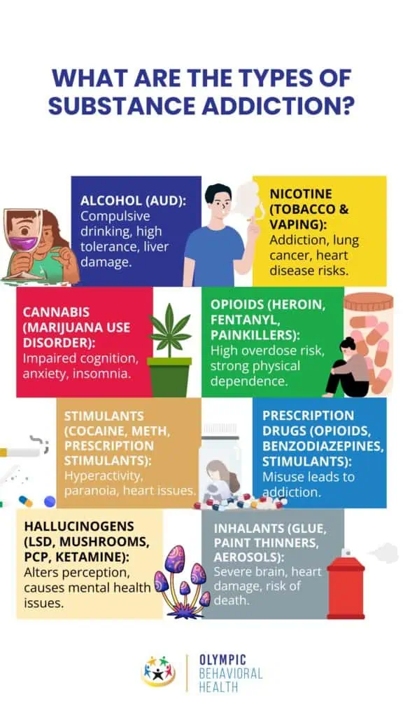
Treatment for substance addiction typically involves a combination of approaches, including detoxification to safely manage withdrawal symptoms, behavioral therapies to address underlying psychological issues, medication-assisted treatment to reduce cravings and prevent relapse, and ongoing support through counseling and support groups.
- Assertive Community Treatment (ACT) provides mental health services in a community setting rather than a residential or hospital setting. ACT is highly individualized. Your treatment plan will focus on your strengths, needs and goals for the future.
- Cognitive Behavioral Therapy (CBT): helps you identify problematic patterns of behavior and thinking. You’ll set goals to find healthier ways to cope.
- Contingency Management: This type of therapy encourages you to set personal goals. When you reach a goal, it’s reinforced with a reward.
- Dialectical Behavior Therapy (DBT): is a type of talk therapy similar to CBT. It’s designed to help you manage intense emotions and understand how your thoughts influence your behaviors.
- Family therapy helps you improve relationships and behaviors within a family or group setting.
- Motivational Enhancement Therapy: This type of therapy encourages you to set attainable goals. A mental health professional will encourage you to take steps to reach these goals.
- A Therapeutic Communities (TC) is a long-term residential treatment that focuses on helping you develop new, healthier values and behaviors related to substance use and other co-occurring mental health conditions.

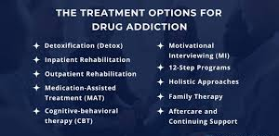

UNIT V – INTERPERSONAL RELATIONSHIPS & SOCIAL WELL-BEING

INTERPERSONAL RELATIONSHIPS
Interpersonal relationships refer to the connections and interactions between two or more people, ranging from brief encounters to enduring bonds.

ASPECTS OF INTERPERSONAL RELATIONSHIPS:
Social Connection:
Interpersonal relationships are the foundation of human connection, providing a sense of belonging, support, and shared experience.
Communication:
Effective communication is crucial for building and maintaining healthy relationships. This includes active listening, expressing oneself clearly, and being mindful of nonverbal cues.
Trust:
Trust is a cornerstone of any strong relationship, built through honesty, reliability, and consistent behavior.
Empathy:
Understanding and sharing the feelings of others is vital for fostering empathy and strengthening bonds.
Mutual Fulfillment:
Relationships thrive when both individuals feel their needs are being met, whether emotional, social, or practical.
Variety:
Interpersonal relationships can take many forms, including family, friendships, romantic partnerships, and professional connections.
Stages:
Relationships evolve through different stages, from initial acquaintance to potential continuation or termination.
IMPORTANCE OF INTERPERSONAL RELATIONSHIPS:
Well-being:
Strong interpersonal relationships contribute to both physical and emotional well-being, providing a support system and reducing stress.
Mental Health:
Problems in interpersonal relationships can contribute to mental health challenges like depression, anxiety, and loneliness.
Development:
Early childhood relationships significantly impact a child's development, influencing their ability to form healthy attachments and navigate social situations.
Success:
Effective interpersonal skills are essential for success in personal and professional life.

BUILDING STRONG INTERPERSONAL RELATIONSHIPS:

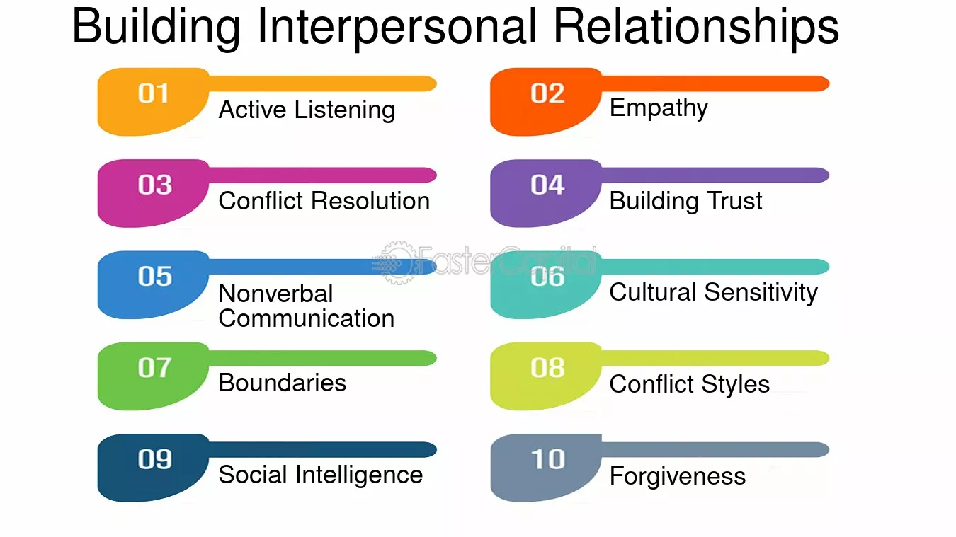
DEVELOPING HEALTHY RELATIONSHIPS AND STRONG COMMUNICATION SKILLS
Developing healthy relationships and strong communication skills involves active listening, clear and honest expression, and understanding non-verbal cues. It also requires building trust, practicing empathy, and setting healthy boundaries.
COMMUNICATION SKILLS:
Active Listening:
Pay full attention to the speaker, make eye contact, and acknowledge their words without interrupting. This shows respect and understanding.
Clear and Honest Expression:
Use "I" statements to express feelings and needs, and be direct and specific in your communication.
Non-Verbal Communication:
Be mindful of your body language, tone of voice, and facial expressions, as these can convey a message even without words.
Choose the Right Time and Place:
Select a time and environment where both parties can focus and communicate openly without distractions.
Seek Clarification:
Don't be afraid to ask for clarification if you are unsure about something.
Avoid Blame and Accusations:
Frame your communication in a way that focuses on your feelings and needs rather than blaming the other person.
Respectful Language:
Use respectful language and tone, even when discussing difficult topics.

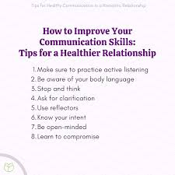
Building Healthy Relationships:
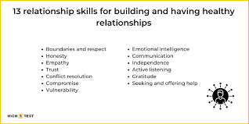
Trust: Trust is built through consistent actions and honest communication. Follow through on promises and be reliable.
Empathy: Try to understand the other person's perspective and feelings.
Respect: Treat your partner with kindness, understanding, and respect for their boundaries.
Compromise: Be willing to find solutions that work for both of you.
Time Together: Schedule dedicated time for quality conversations and shared activities.
Appreciation: Express gratitude and positive feelings towards your partner.
Conflict Resolution: Learn to address conflicts constructively and find mutually agreeable solutions.
Boundaries: Establish and respect personal boundaries.
Positive Feedback: Offer constructive feedback and celebrate progress.

PEER PRESSURE:
Definition:
Peer pressure is the social influence exerted by a peer group on an individual, encouraging them to adopt specific behaviors, attitudes, or values.
Types:
Peer pressure can be positive (encouraging healthy behaviors or academic achievement) or negative (leading to risky behaviors like substance abuse or delinquency).
Examples:
Fitting in with a group by adopting their fashion choices, engaging in risky behaviors like drinking or smoking, or changing one's opinions to align with the group's views.
Impact:
Peer pressure can affect self-esteem, social acceptance, and decision-making abilities, and can lead to both positive and negative outcomes.
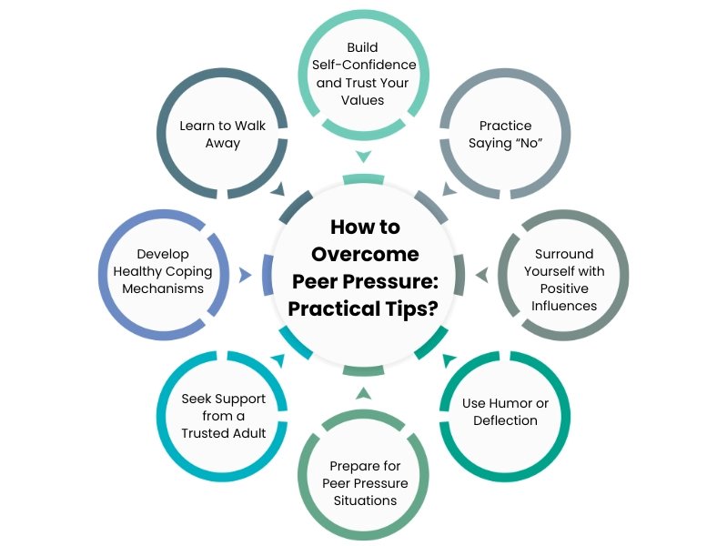
CONFLICTS:
Definition:
A conflict is a disagreement or clash between individuals or groups, involving opposing ideas, interests, or purposes.
Causes:
Conflicts can arise from various factors, including competition for resources, differences in values or beliefs, communication breakdowns, or power struggles.
Types:
Conflicts can be interpersonal (between individuals), intergroup (between groups), or intrapersonal (within an individual).
Impact:
Conflicts can lead to negative emotions like anger, resentment, and anxiety, and can disrupt relationships, productivity, and overall well-being.
Resolution:
Conflicts can be resolved through communication, negotiation, mediation, or other constructive strategies that address the underlying issues and promote understanding.

EMPATHY:

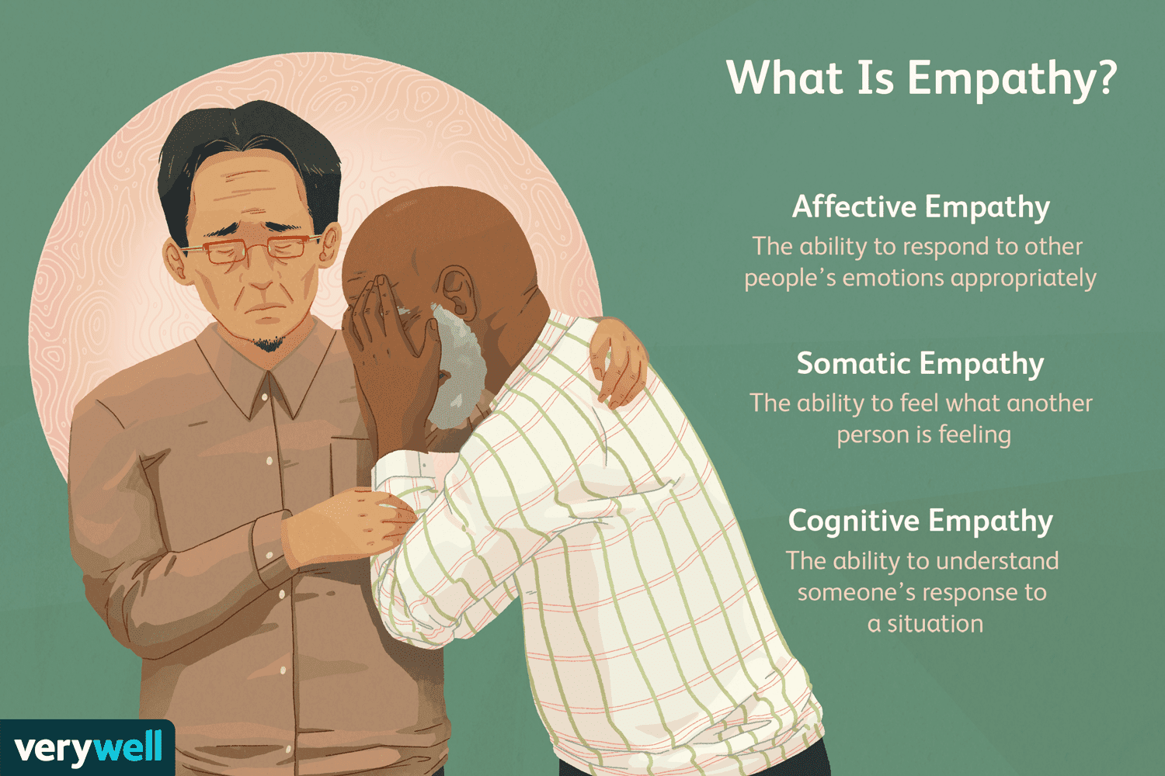

Empathy plays a crucial role in enhancing well-being, strengthening communities, and fostering social support. It facilitates stronger social connections, reduces prejudice, and promotes prosocial behaviors that benefit both individuals and society. By fostering understanding and compassion, empathy contributes to a more inclusive and supportive environment.
WELL-BEING:
Positive emotions and reduced stress:
Empathy, particularly when expressed, can lead to positive feelings of happiness and gratitude, both for the empathetic individual and the recipient. This, in turn, can reduce stress and improve overall well-being.
Stronger social connections:
Empathy enables individuals to connect with others on a deeper level, fostering stronger and more supportive relationships.
Improved mental health:
Empathy is linked to altruistic behaviors and can reduce prejudice and conflict, all of which contribute to improved mental health.
Community:
Enhanced social cohesion:
By fostering understanding and compassion, empathy helps build stronger communities where individuals feel valued and respected.
Reduced stigma:
Empathy plays a vital role in reducing the stigma surrounding mental health issues, creating safer spaces for individuals to discuss their challenges.
Inclusive environments:
Empathetic communities are more inclusive, celebrating diversity and promoting a sense of belonging for all members.
Social Support:
Increased prosocial behavior:
Empathetic individuals are more likely to offer support to others, strengthening the social support network within a community.
Mediation of social support:
Empathy can mediate the relationship between adversity and positive outcomes, such as psychological distress, by promoting perceived social support.
Strengthened social bonds:
Empathy allows individuals to better understand and respond to the needs of others, leading to stronger social bonds and a more supportive network.
In essence, empathy acts as a catalyst for positive social interactions, fostering stronger relationships, promoting well-being, and building more cohesive and supportive communities.

